**STEP 1: Make a monthly billing spreadsheet**

**Objective: We will use data from The Portal and Chartio to create a google docs file called “the monthly billing spreadsheet”. This file will be constructed in a way so that we see only the clients with manual billing.**

1. **EXPORT CHARTIO DATA**

Log in to Chartio

Click on Billing Flags

Filter by Month

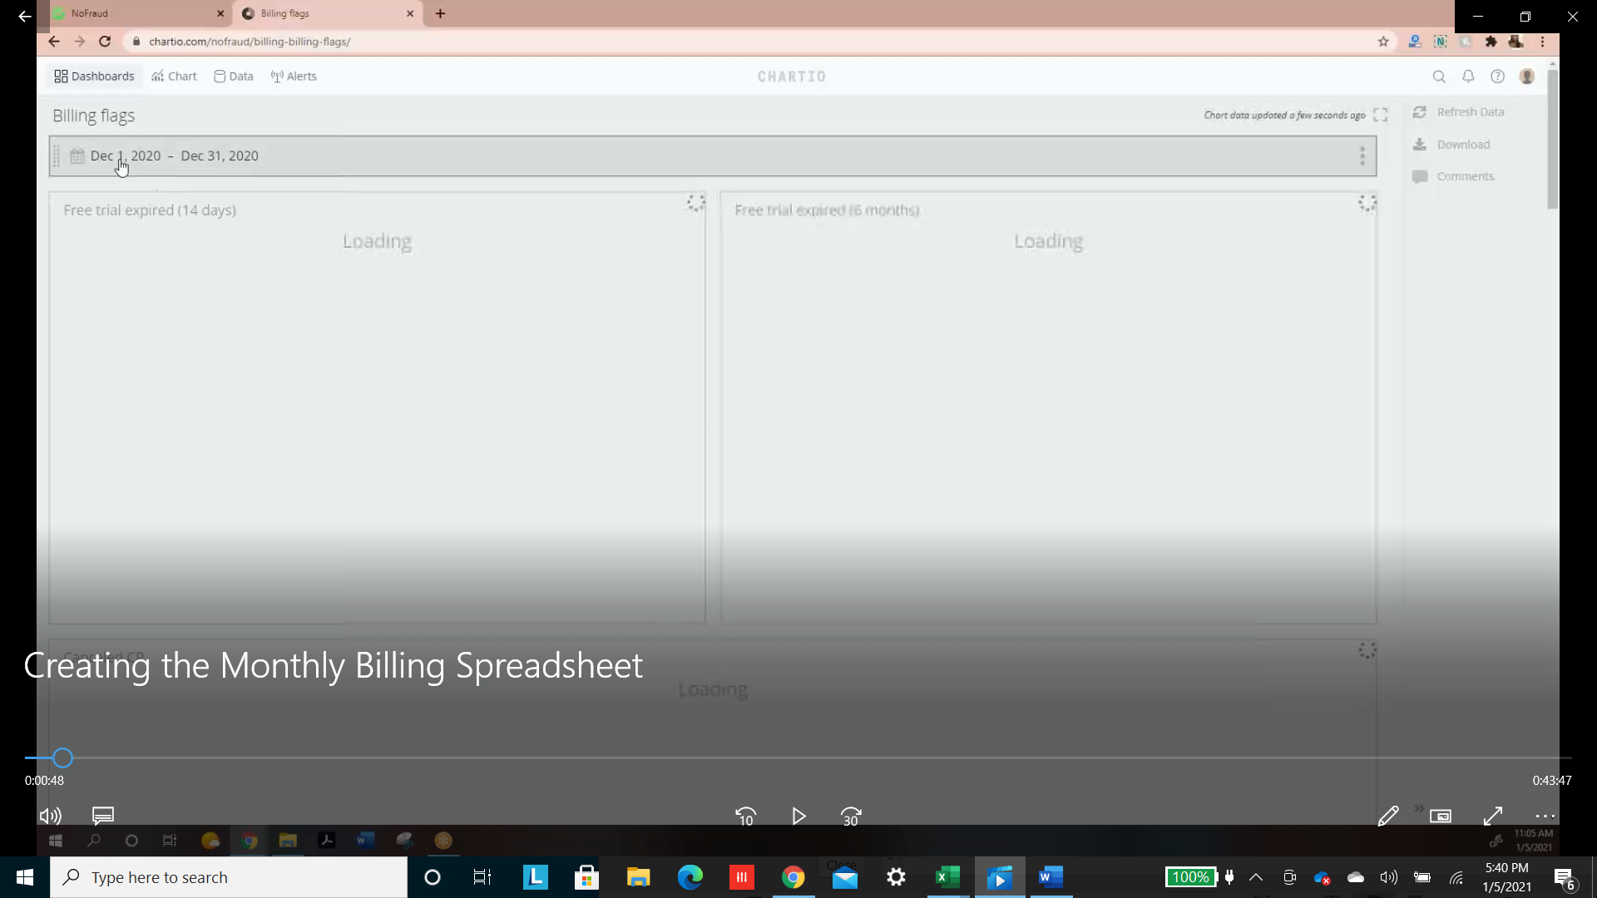

Scroll down to “Billing Export” and export this. This data will be used later.

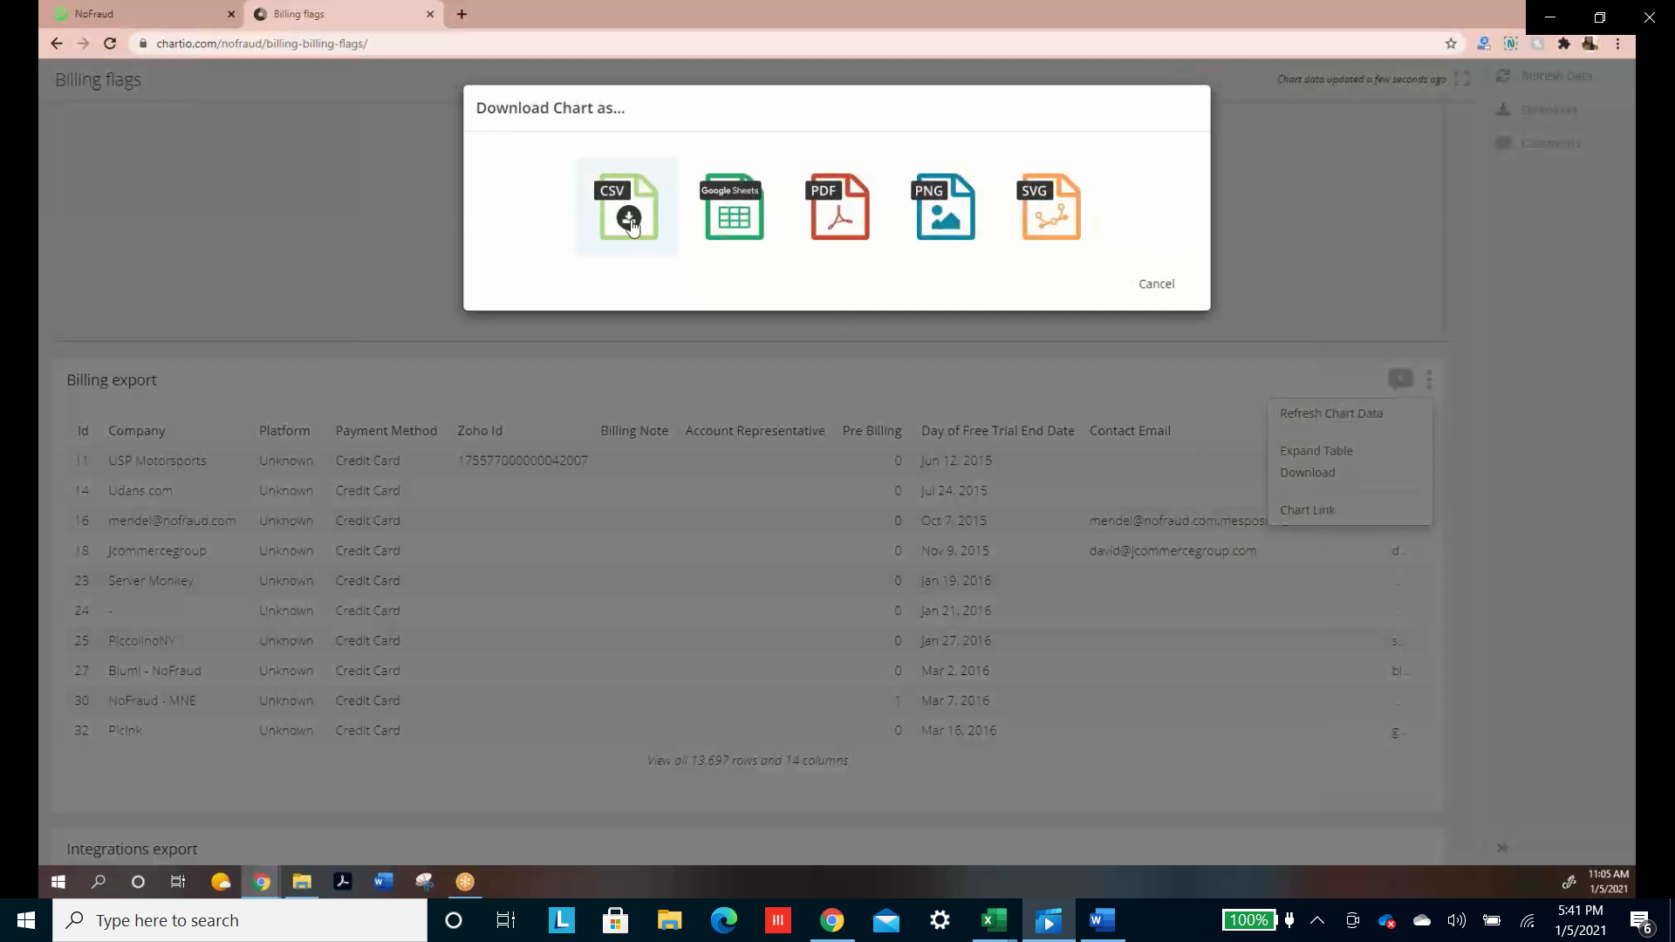

1. **CREATE SPREADSHEET**

In Google Docs, spreadsheets are titled “November 2020 – Billing”. Copy and paste a previous month’s heading into a new excel file. It should look like this

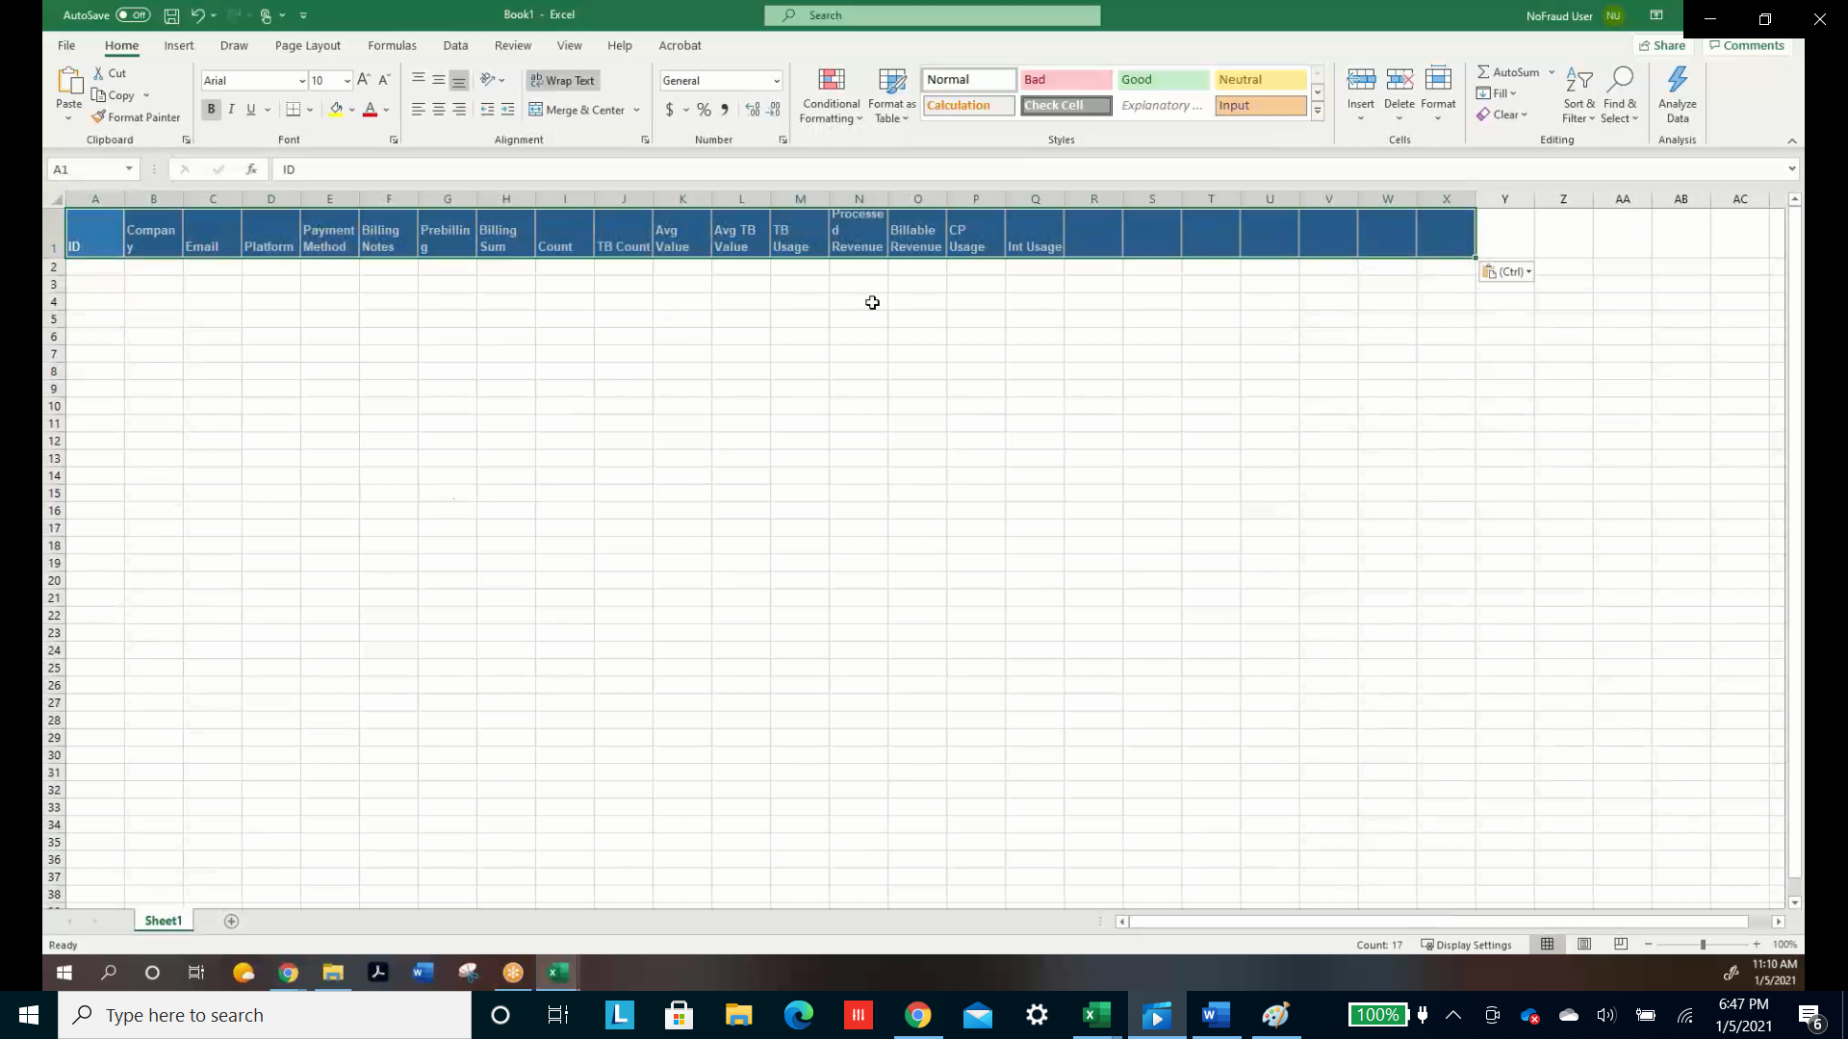

1. **COLLECT PORTAL DATA**

In the Portal, Click on “Customers” on the left then “Billing on the top. Filter by date and select last month

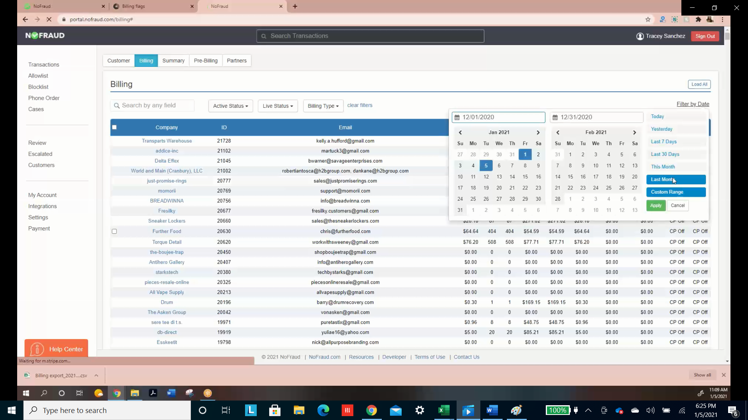

Manually copy everything from the billing tab in the portal and paste it into your new excel file

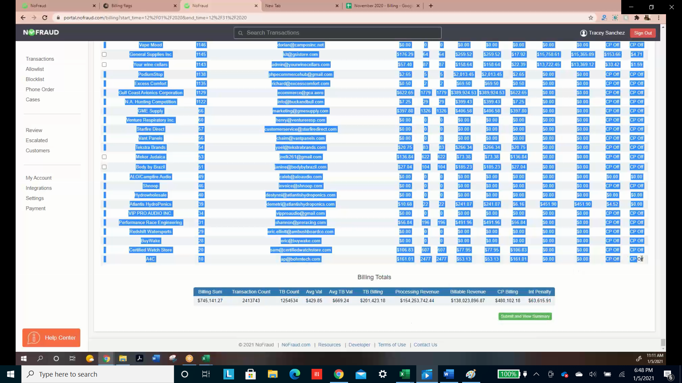

This won’t match up to the headers, as seen below. So we will need to edit this file

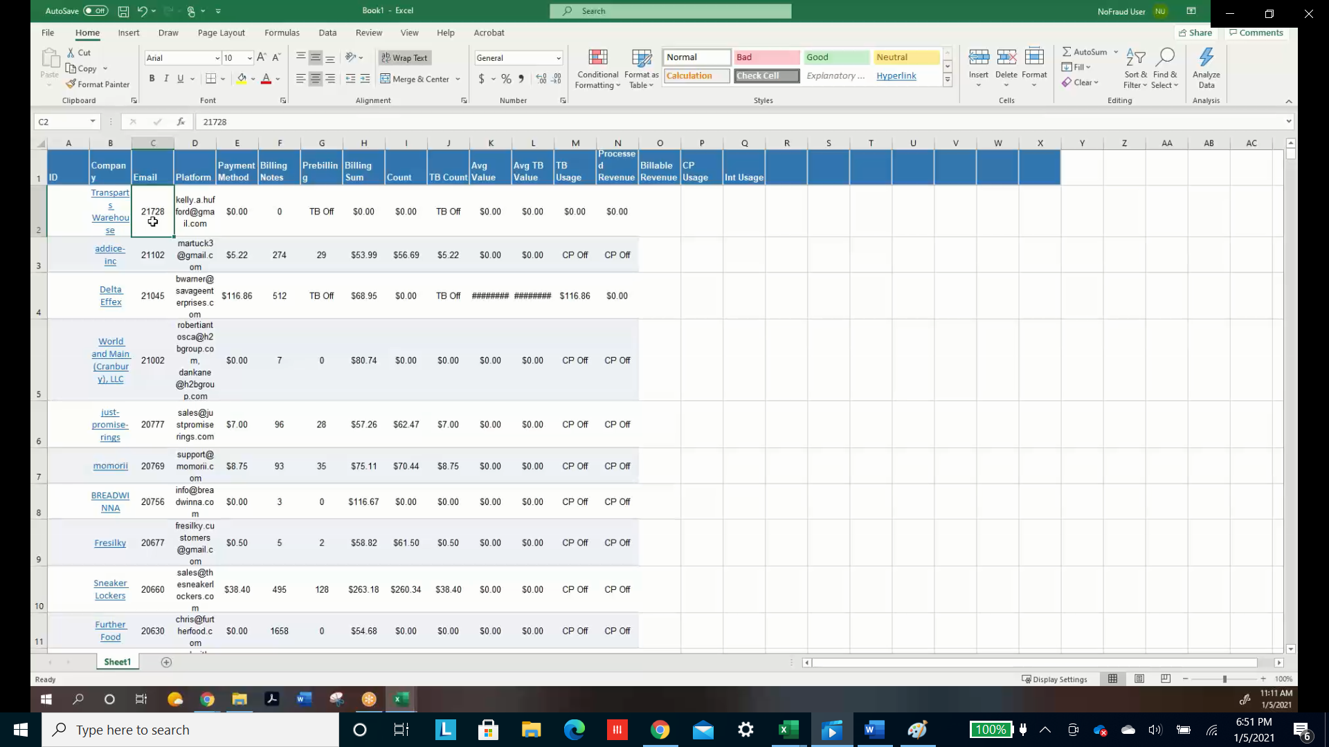

Use copy and paste to move the email entries into the ID column and then platform entries into the email column. It should look like this

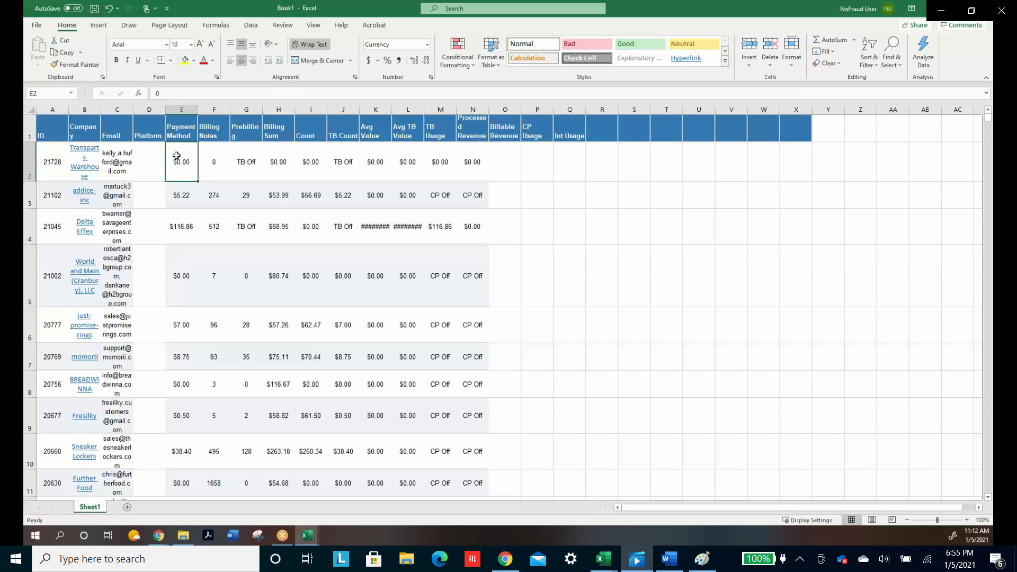

Shift the entries in the payment column and following to the right. The result should look like this

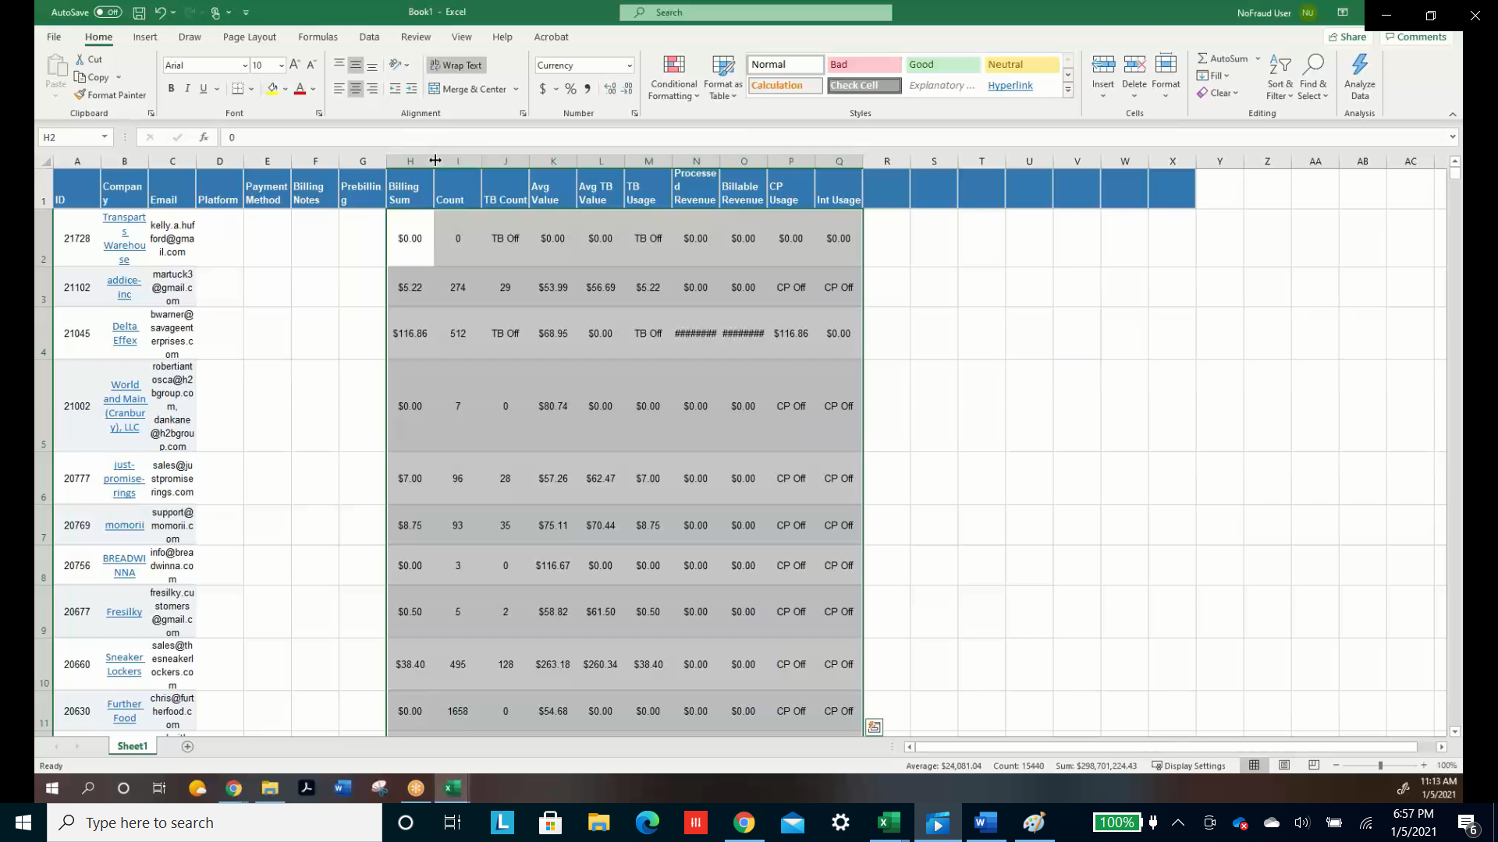

1. **Use VLookup with the Billing Export file from Chartio to fill in the empty columns in this new file**

Lookup value is the ID so the first entry of the formula is A2

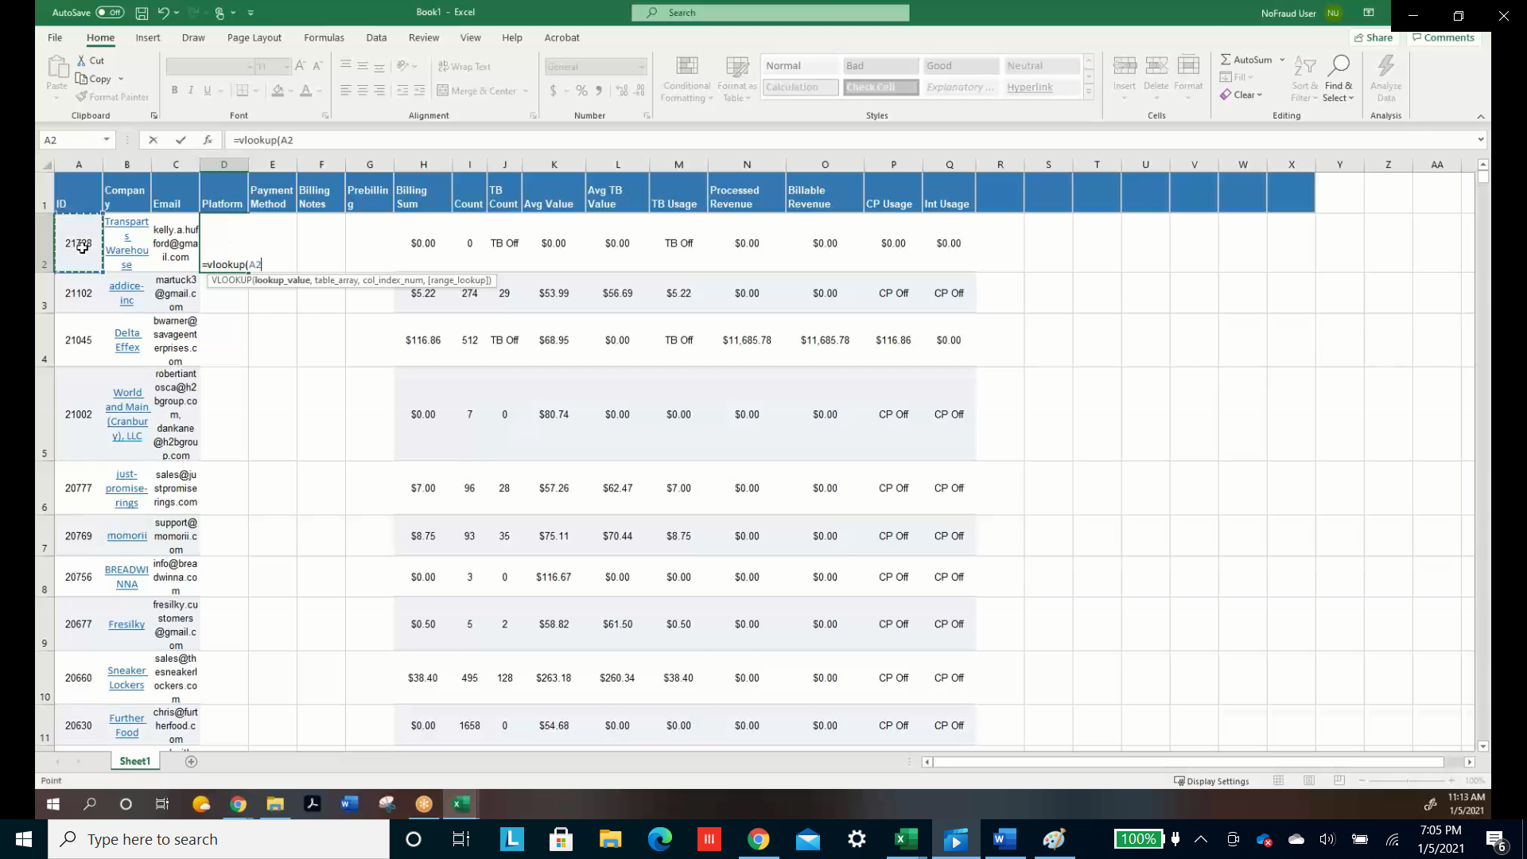

The table we are performing the lookup on is the chartio export so we can click here for the second entry 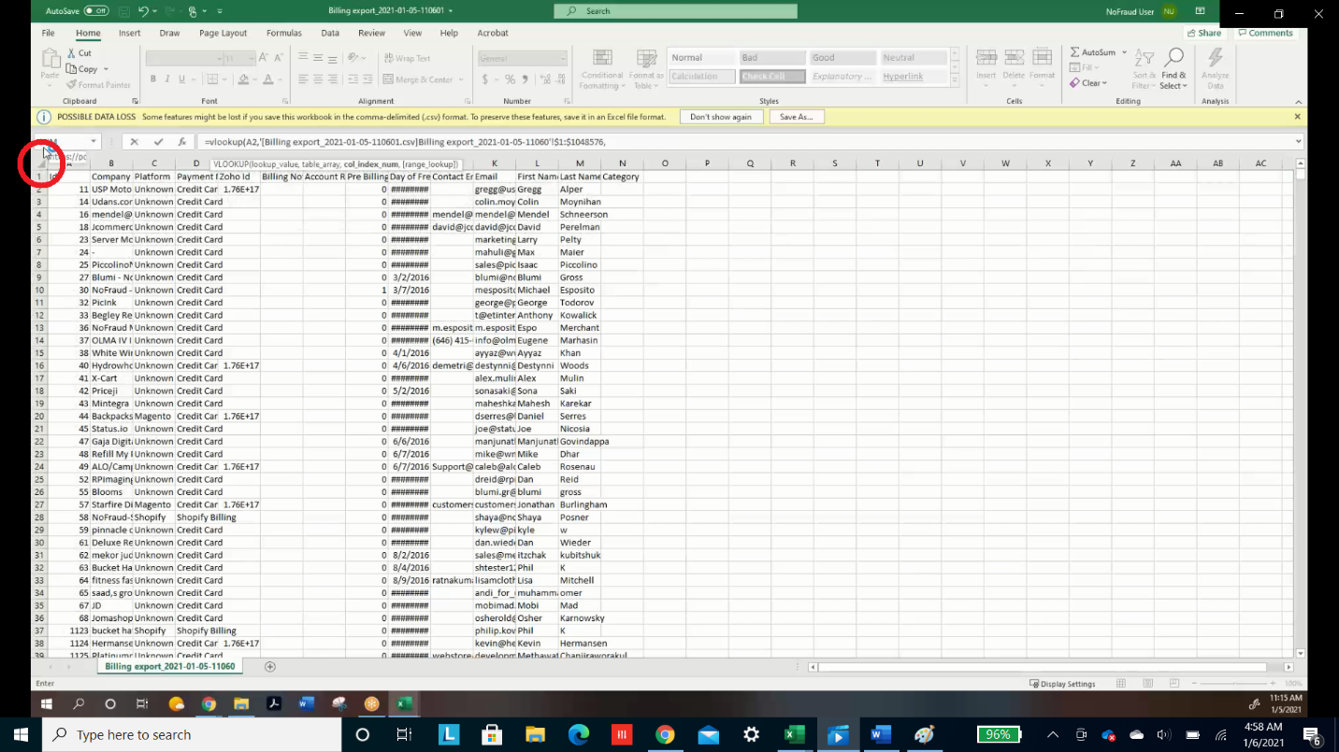

The next entry is the number 3, because that column corresponds to platform in the Chartio table

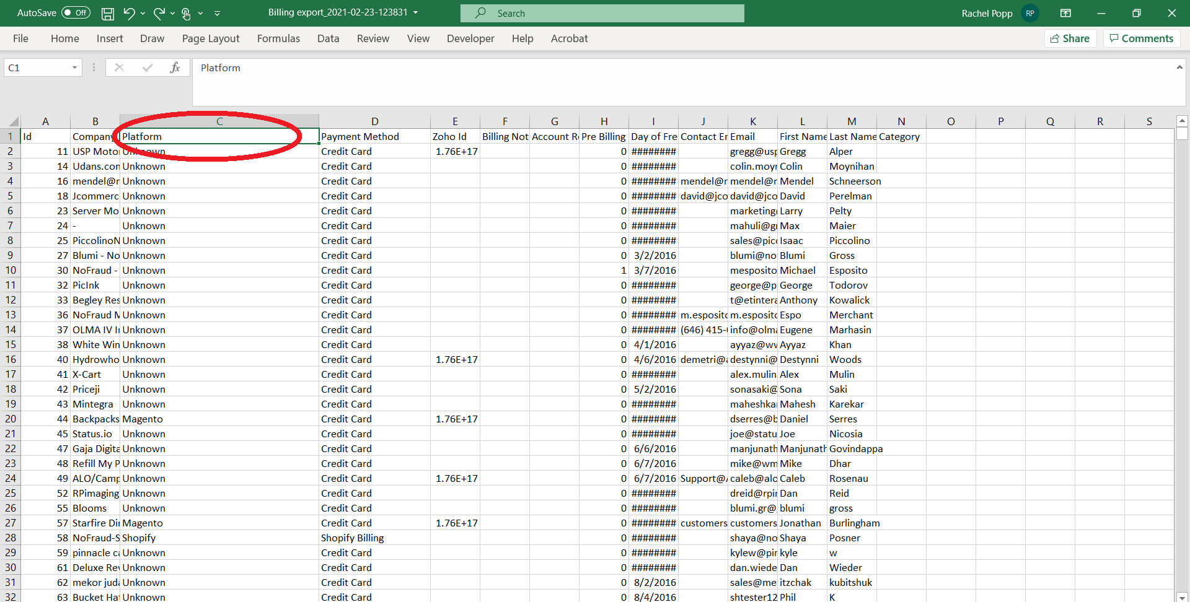

The last entry of the formula will always be “false”. So the complete formula will look like below. Double click the bottom right of your cell to copy the formula to all rows.

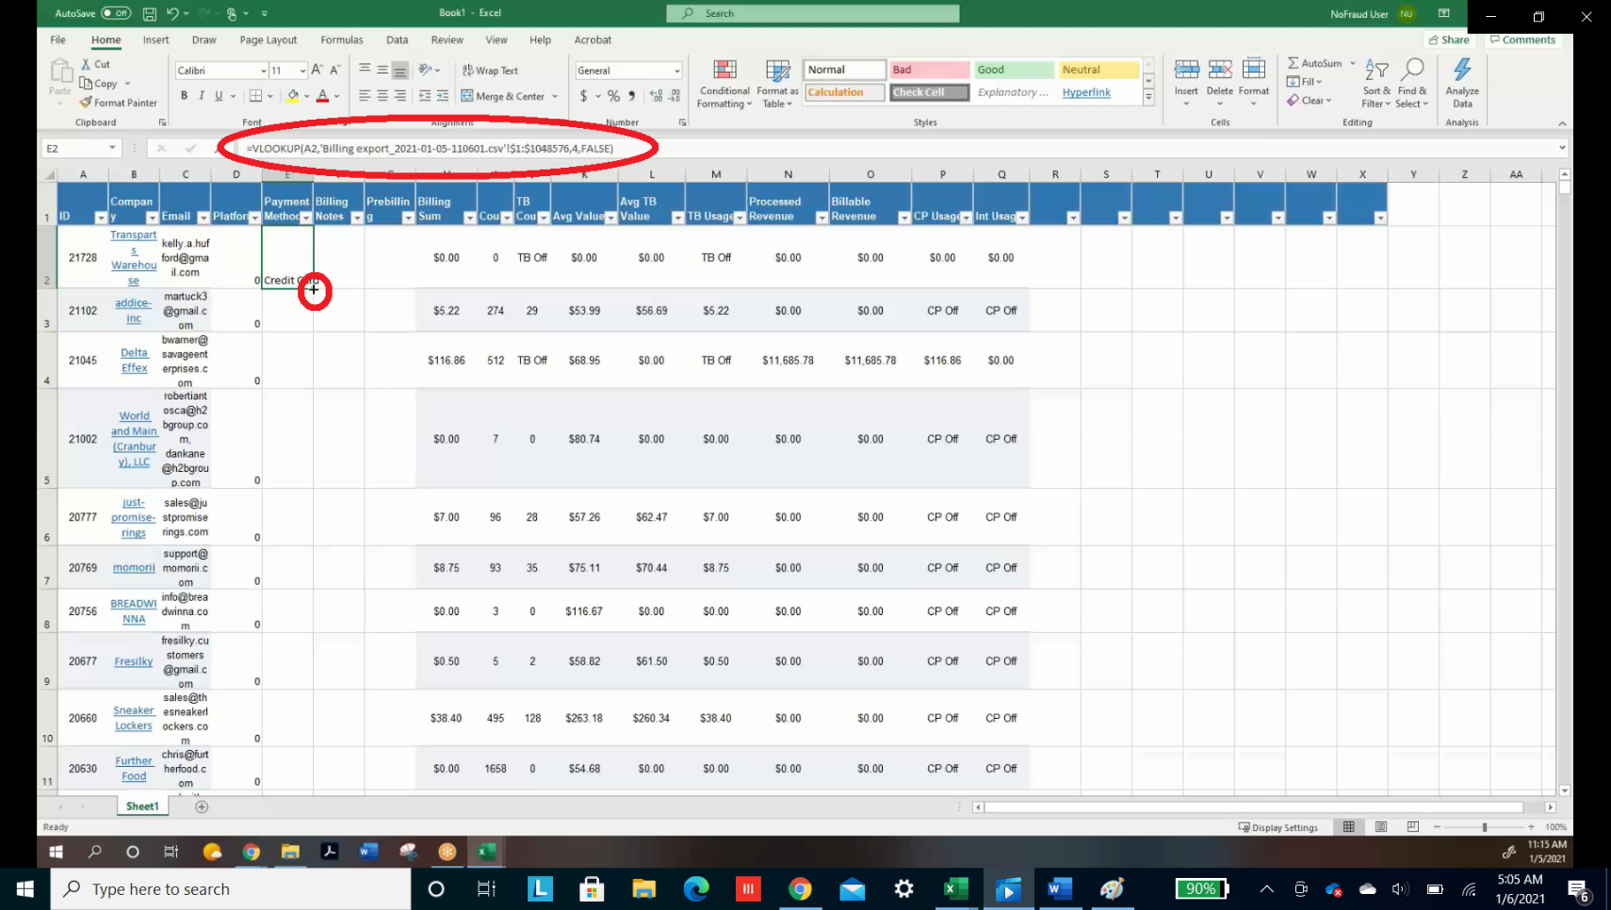

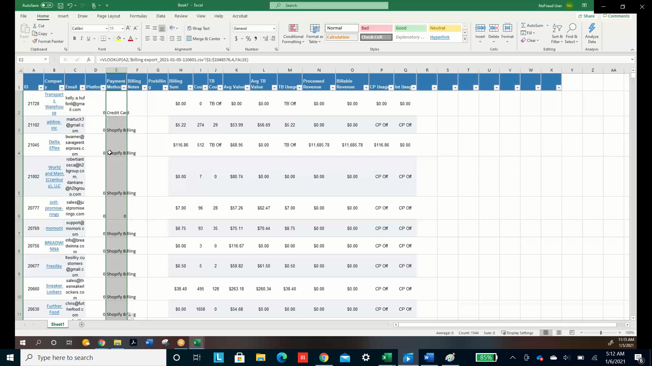

Repeat this process to fill in the Billing Notes and Prebilling Columns.

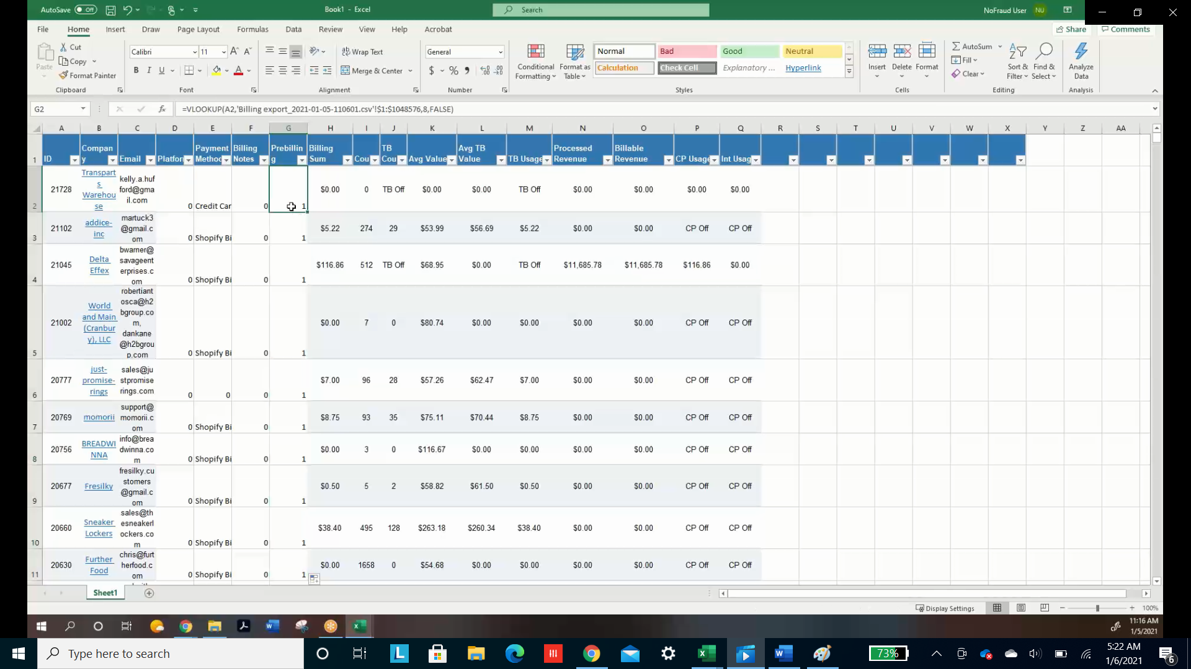

Replace the 0’s with “No” and 1’s with “Yes” in the prebilling column. This is done by filtering the column for 1’s, Typing “Yes” in the first cell. Ctrl Shift downarrow, then ctrl d. Do not drag because it will fill the unfiltered cells as well. Repeat the process to instead replace the 0’s with “No”s.

Remember to remove the filters after this

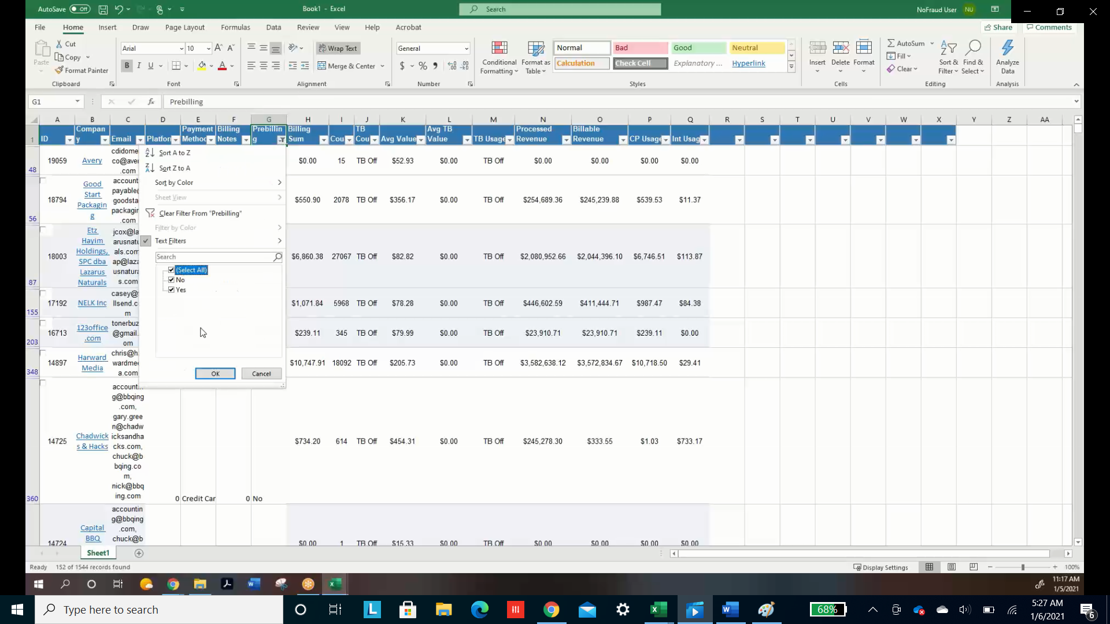

1. **The file is ready to be stored in googledocs now.**   
     
   Go to the previous month’s googledocs file and make a copy.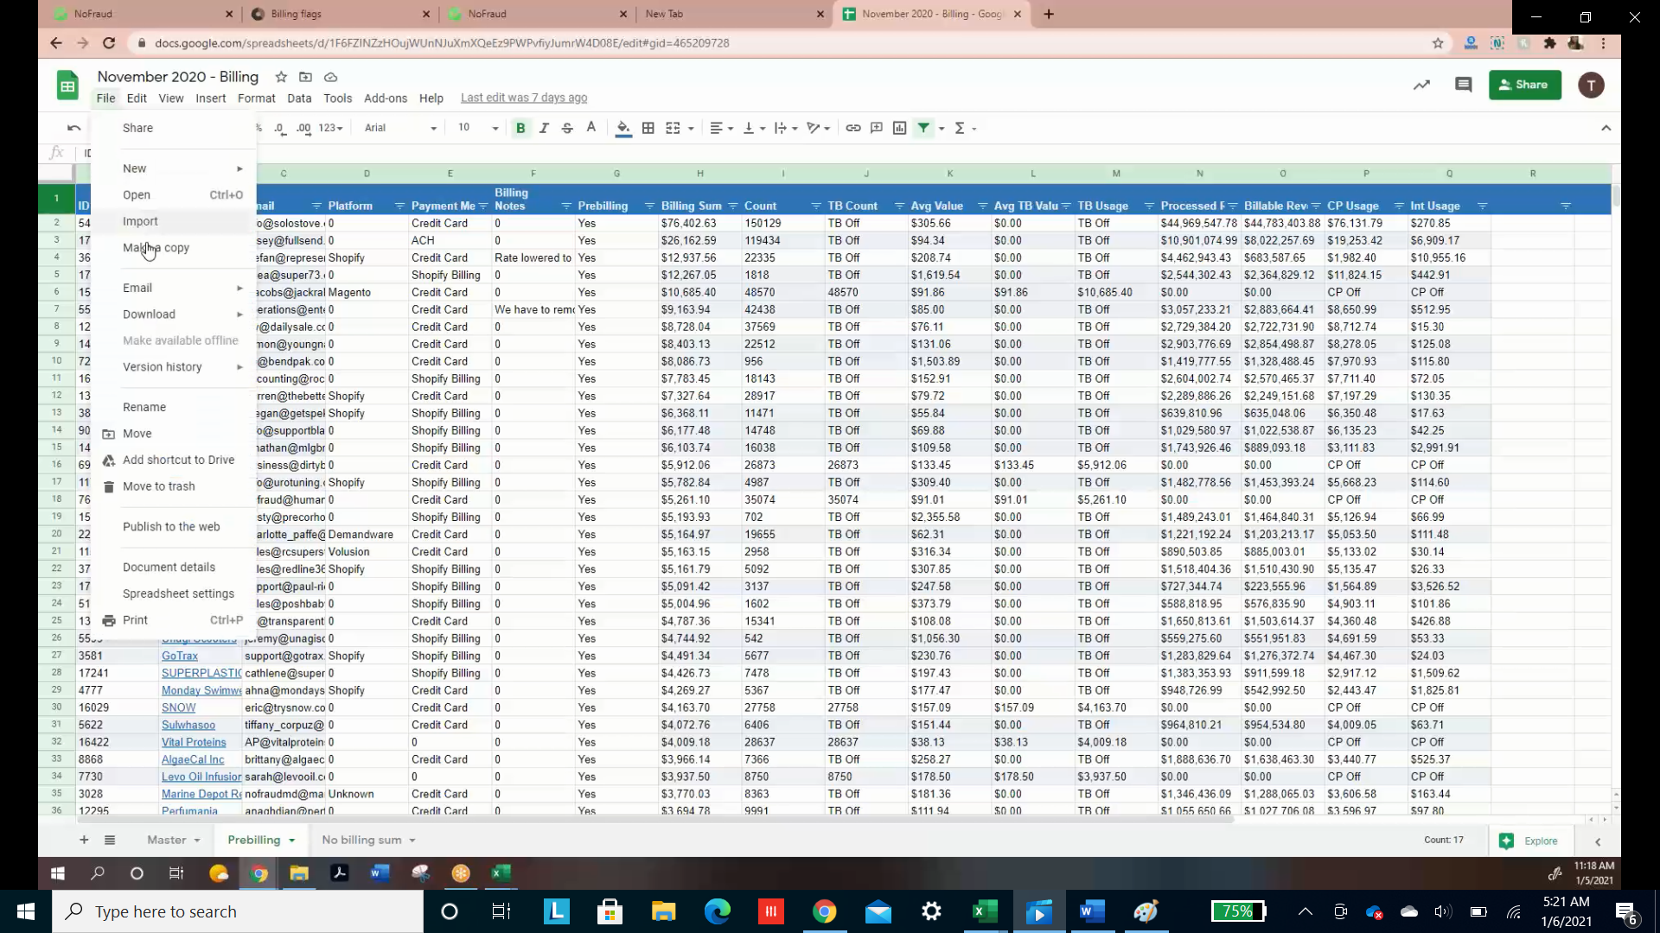

Title your new googledocs file with the new month, and delete the data in it (you can click on the second row number and ctrl shift downarrow. Add an empty row at the bottom before doing this). There are three tabs at the bottom to delete data from. Also make sure to unhide all columns because some will be hidden in the Master tab.

Copy and paste your Excel data into the master tab of the googledocs file.

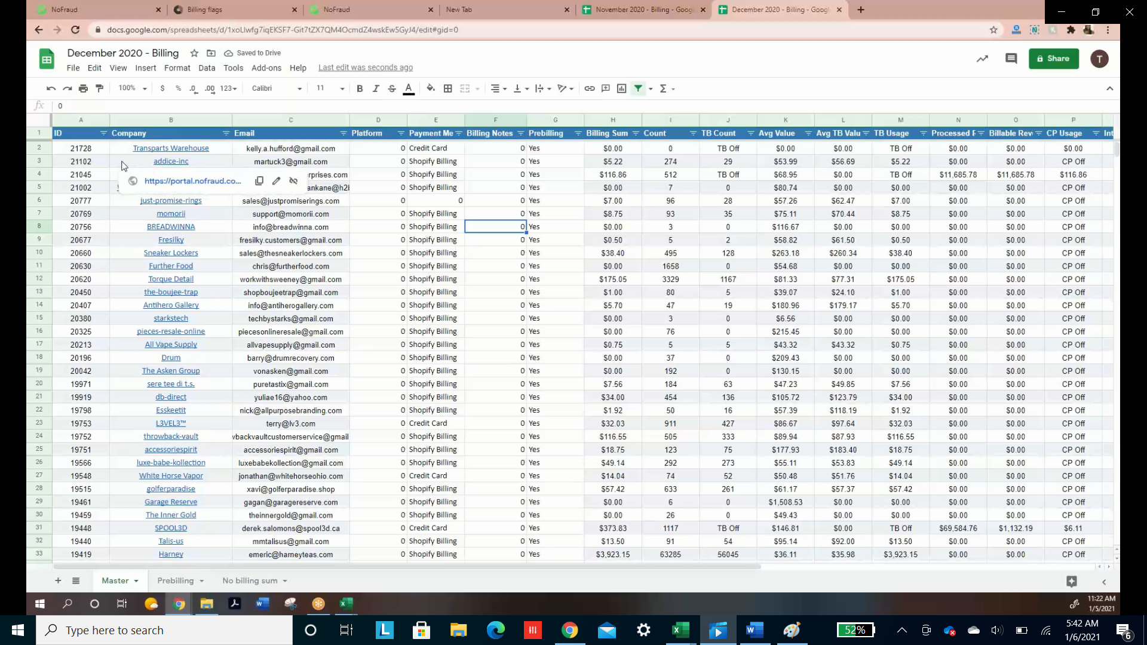

1. **The last step is to move the prebilling customers and No billing Sum customers to their respective tabs.**

Filter for $0 billing

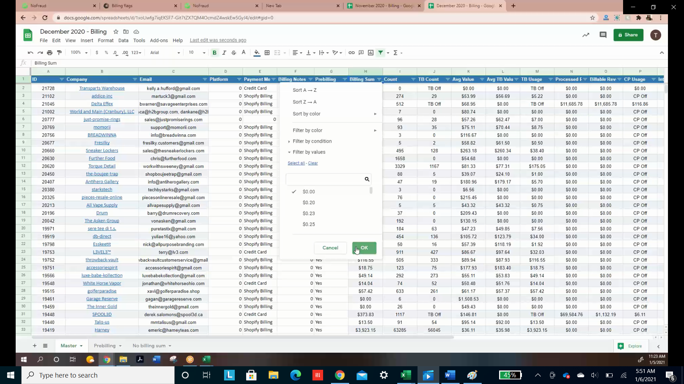

Copy and paste this into the “No Billing Sum” Tab and sort by the Count column from Z to A  
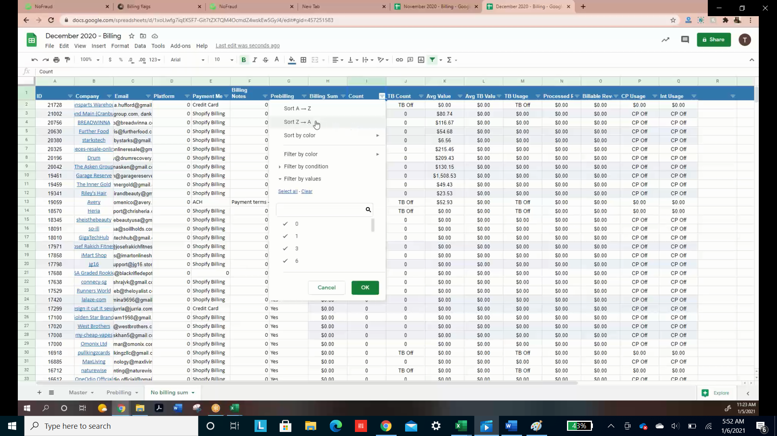

Delete the “No Billing Sum” rows from your master tab

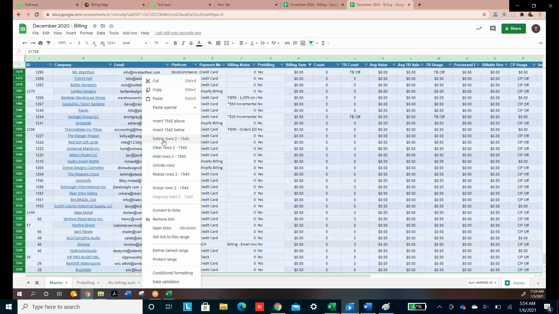

In the master tab, remove the filter from “Billing Sum” and create a filter on “Prebilling”. Filter “Prebilling” for Yes.

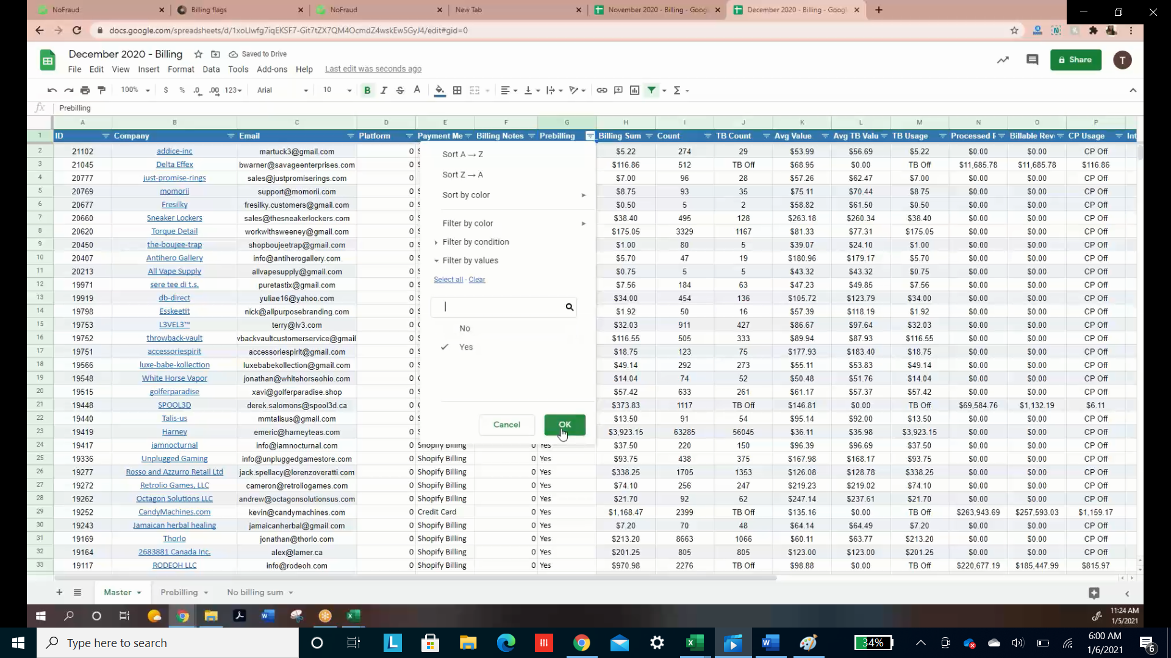

Similar to before, copy this into the prebilling tab. Sort by “Billing Sum” Z - A. Delete the rows from the master tab, then remove the filter from the master tab.

Hide Columns A, G, and I – Q for your convenience

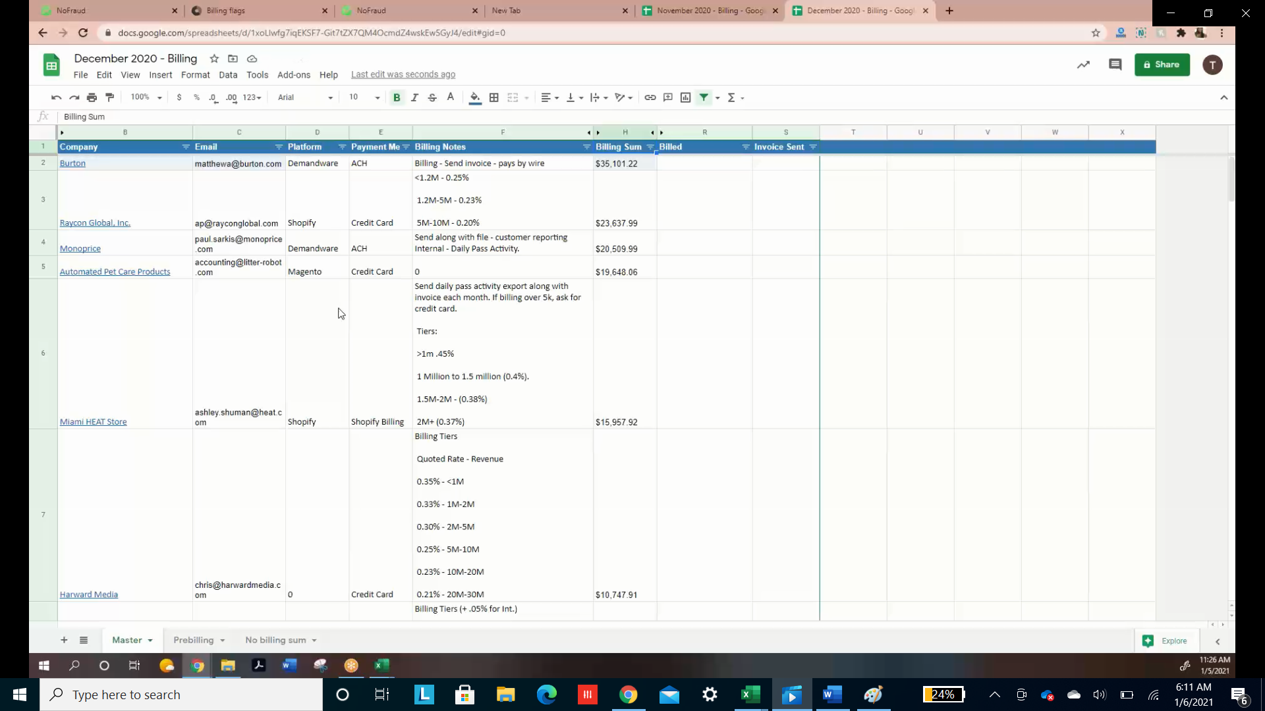

Sort the master by Billing Sum from highest to lowest.